COLLEGE NAME:JP COLLEGE OF ENGINEERING
COLLEGE CODE:9512
PROJECT NAME: SMART WATER MANAGEMENT
PROJECT ID:Proj_211932_Team_1
TEAMS NUMBERS:
- M.SAMYDURAI,951221106040
Email:samydurai2004@gmail.com
- S.SUNDARAN, 951221106304
Email:sundaranvkp25@gamil.com
- M.KALAISEVAN,951221106016
Email:junga4736@gmail.com
SMART WATER MANAGEMENT:
PHASE 1:PROBLEM DEFINITION AND DESIGN THINKING
Smart water management :
Smart water management involves using technology to monitor, control, and optimize water usage efficiently. This can include sensor-based systems for detecting leaks, automated irrigation systems, and data analytics to improve overall water conservation. It’s a crucial approach for sustainable resource utilization and addressing water scarcity issues.
Project defition:
A smart water management project aims to implement advanced technologies and data-driven solutions to optimize the use of water resources. This could involve deploying sensors to monitor water quality, consumption, and detect leaks. Automation systems can be integrated for efficient irrigation in agriculture or smart metering in urban areas. The project would likely include data analytics to provide insights, improve decision-making, and contribute to sustainable water usage.

PROJECT DEFINITION AND DESIGN:
1.Project Definition:
- Objectives: Clearly state the goals of the project, such as improving water efficiency, reducing waste, or ensuring water quality.
- Scope: Define the geographical area or specific water systems the project will cover.
- Stakeholders: Identify key stakeholders, including government bodies, communities, and industries.
2.Research and Analysis:
- Water Usage Assessment: Analyze current water usage patterns and identify areas for improvement.
- Technology Review: Explore available technologies for monitoring, automation, and data analytics in water management.
3.System Components:
- .Sensor Networks: Specify types of sensors (e.g., flow meters, quality sensors) and their strategic placement.
- Automation Systems: Design automated processes for tasks like irrigation, leak detection, and water distribution.
- Data Analytics Platform: Choose or design a platform for processing and analyzing collected data.
4.Integration:
- Interconnected Systems: Ensure seamless communication between sensors, automation systems, and the analytics platform.
- Compatibility: Confirm compatibility with existing infrastructure and technologies.
5.Risk Assessment:
- Identify Risks: Anticipate potential challenges, such as technical issues, data security concerns, or resistance from stakeholders.
- Risk Mitigation: Develop strategies to mitigate or manage identified risks.
6.Regulatory Compliance:
- Legal Requirements: Understand and comply with local and national regulations related to water management and technology use.
7.Budget and Resources:
- Cost Estimation: Provide a detailed breakdown of costs, including equipment, technology implementation, and ongoing maintenance.
- Resource Allocation: Define the human resources and expertise required for the project.
8.Timeline:
- Project Phases: Divide the project into manageable phases with specific milestones.
- Implementation Schedule: Develop a timeline for each phase, considering dependencies and potential delays.
9.Monitoring and Evaluation:
- Performance Metrics: Establish measurable indicators to assess the success of the project.
- Monitoring Plan: Develop a plan for continuous monitoring and evaluation of the smart water management system.
10.Documentation and Communication:
- Document Design Choices: Maintain clear documentation of the chosen technologies, processes, and design decisions.
- Communication Plan: Establish a plan for keeping stakeholders informed about project progress.
Remember, this is a high-level outline, and the specifics will depend on the unique characteristics and goals of your smart water management project. If you have specific questions or need more detailed information on any of these points, feel free to ask!
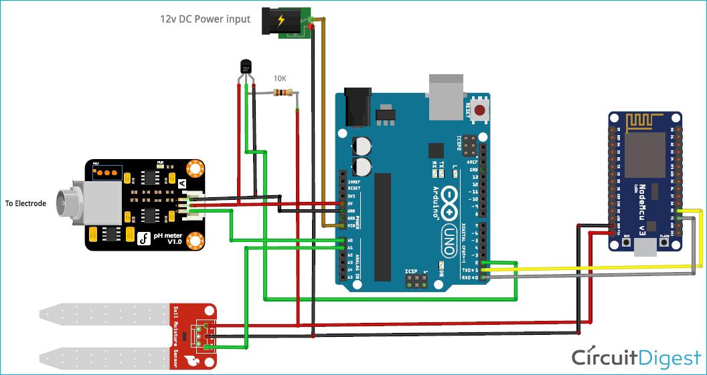
Circuit diagram :

